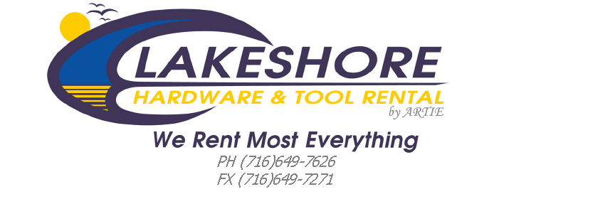

Handheld Equipment | Walk Behind Mower | Lawn Tractor Mower | Zero Turn Mower | Snowblower  2 Stage & Larger
$69.95 plus Parts* | $109.95 plus Parts* | $149.95 plus Parts* | $169.95 plus Parts* | $109.95 plus Parts*
- Check Spark  - Check Compression  - Inspect Spark Plug & Replace if Necessary  - Service Air Filter -Replace if Necessary  - Remove/Clean Bar & Sharpen Chain (Chainsaws)  - Cleaning of Equipment upon request only&additional charges will apply  Generators&  Pressure Washers  $79.95 plus Parts*  - Check Spark  - Check Compression  - Inspect Spark Plug & Replace if Necessary  - Service Air Filter -Replace if Necessary  - Change Engine Oil  - Treat w/ Pump Saver (Pressure Washers)  - Test Output/Input (Generators) | - Check Spark  - Check Compression  - Blade Sharpening & Balancing  - Drain & Replace Engine Oil  - Replace Spark Plug  - Service Air Filter -Replace if Necessary  - Inspect Belt(s) if Applicable  - Quick Clean of Underside of Deck  - Cleaning of Equipment upon request only &additional charges will apply | - Check Spark  - Check Compression  - Record Hour Meter  - Blade Sharpening & Balancing  - Replace Oil Filter & Change Engine Oil  - Replace Spark Plug(s)  - Replace Air Filter& Pre-Filter  - Replace Fuel Filter, if Necessary  - Grease all Fittings  - Test Battery &Charging System  - Inspect Belts, Spindles &Pulleys  - Set Tire Pressures  - Level the Deck  - Cleaning of Equipment upon request only &additional charges will apply | - Check Spark  - Check Compression  - Record Hour Meter  - Blade Sharpening & Balancing  - Replace Oil Filter & Change Engine Oil  - Replace Spark Plug(s)  - Replace Air Filter& Pre-Filter  - Replace Fuel Filter, if Necessary  - Grease all Fittings  - Test Battery &Charging System  - Inspect Belts, Spindles &Pulleys  - Set Tire Pressures  - Level the Deck  - Cleaning of Equipment upon request only &additional charges will apply | - Check Spark  - Check Compression  - Replace Spark Plug  - Change Engine Oil  - Grease all Fittings  - Lube Cables  - Check Belt(s)  - Inspect the Drive System/Disc  - Check Gearbox Oil Level  - Set Tire Pressures  - Adjust Skid Shoes  SINGLE STAGE UNITS  $79.95 plus Parts*  - Check Spark  - Check Compression  - Replace Spark Plug  - Inspect Auger  - Change Engine Oil  (if Separate)
*** Prices shown reflect overall labor prior to the addition of necessary parts***
(Tune up Parts that are not included spark plugs, filters, etc)Oil & Fuel Charges Apply---updated 1-22-26 ***

